Business insights summary
Net profit=123.79M
Total Cost of good=282.16M
Complete delivery percentage=78%
Max discount=20%
Net sale=405.95M
Gross sale=470.30M
Average customer lifecycle=33.31 months
Cancelation rate=10.94
January, July, August are most profitable months.
Africa has highest sale.
Payment methods are equally distributed.
Most of the shopping is done by mobile.
Our most of the customers are young.
Our most of the customers are Men.
Top 8 loyal customers
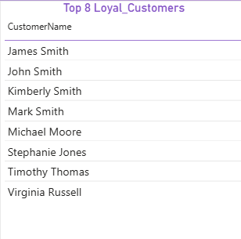

Sales Matrix
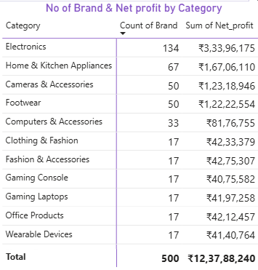
Top 8 Products
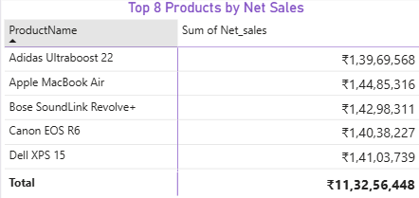

Top 8 brands by Sales
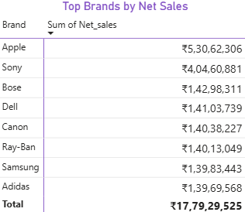
Top 8 Customer by Net Sales
